Project Report Template

1.Introduction

1:1 Overview

* My project is about graphic designing with canva(Resume)

1:2 Purpose

* Through this canva use for editing.

2.Problem definition and design thinking

2:1 Empathy Map

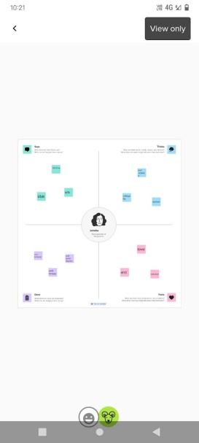

2:2 Brainstorm Map

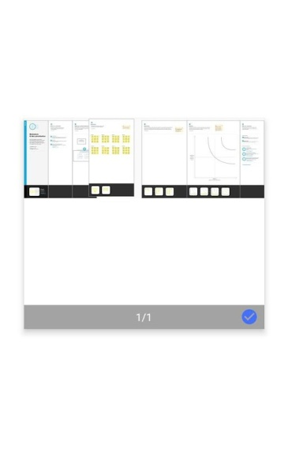

3.Result

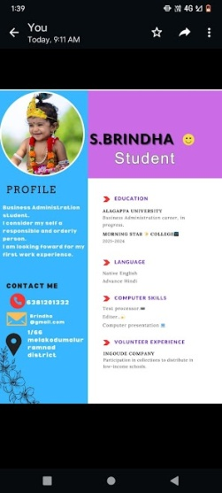

4. Advantage & disadvantage

* This is very useful for us even a non designer can become a designer using canva. Disadvantage there are lots of premium are there.

5. Application

* This canva application is helpful for college students, and also for entrepreneur.

6.Conclusion

* This canva is very helpful to our personal use and study purpose.
* Through this canva we can learn so many things.